--------------------------------SQL Assignment- 2-joins---------------------------------

**PIZZACOMPANY TABLE :**

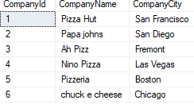

**FOODS TABLE:**

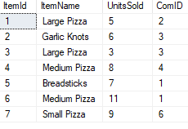

**WATERPARK TABLE :**

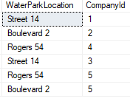

**Q1> Select the items and units sold by each pizza company**

Query: Select P.CompanyName,F.ItemName,F.UnitsSold

from PizzaCompany P inner join

Foods F on P.CompanyId=F.ComID;

OUTPUT:

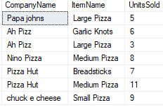

**Q2>Join 2 tables and get the out put**

Query: select P.*,F.*

from PizzaCompany P inner join

Foods F on P.CompanyId=F.CompanyID;

OUTPUT:

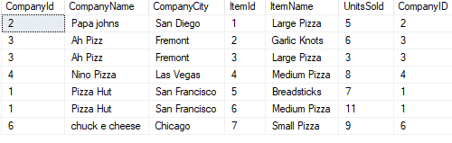

**Q3>Join the 3 tables and where conditions.**

Query: select P.*,F.ItemName,F.UnitsSold,W.WaterParkLocation

from PizzaCompany P inner join

Foods F on P.CompanyId=F.CompanyID

inner join

WaterPark W on P.CompanyId=W.CompanyId

where P.CompanyCity<>'Fremont'

order by P.CompanyId;

OUTPUT:

